**Real time Analytics dashboard - Manufacturing Sector**

GOKULNATH K & E24755

**Overview**

A Real-Time Analytics Dashboard in manufacturing provides instant visibility into production metrics, equipment performance, and supply chain data. It allows data analysts to monitor operations, identify inefficiencies, and make quick decisions to optimize processes. With live updates from machines and sensors, analysts can track key performance indicators (KPIs) like Overall Equipment Effectiveness (OEE) and downtime. This helps improve productivity, reduce costs, and enhance predictive maintenance efforts.

**Objective**

1. Monitor Key Performance Indicators (KPIs): Track real-time metrics such as production output, cycle time, and Overall Equipment Effectiveness (OEE) for immediate insights.
2. Optimize Production Efficiency: Identify bottlenecks, reduce downtime, and improve equipment utilization by analyzing live data.
3. Enhance Quality Control: Detect quality issues early by monitoring defect rates and deviations in production processes.
4. Enable Predictive Maintenance: Use real-time data to predict and prevent equipment failures, reducing unplanned downtime.
5. Improve Supply Chain Visibility: Monitor inventory levels, lead times, and logistics in real-time to optimize procurement and inventory management.
6. Facilitate Data-Driven Decisions: Provide actionable insights based on real-time data to support fast, informed decision-making.
7. Increase Overall Operational Transparency: Offer a clear and comprehensive view of the entire manufacturing process for better oversight and control.

**Assigned Task(s)**

* Real time Analytics dashboard - Manufacturing Sector.

**Task Details**

* **Task 36 :** A Real-Time Analytics Dashboard in manufacturing provides live insights into production, equipment performance, and supply chain metrics, enabling quick, data-driven decisions. It helps data analysts optimize efficiency, reduce downtime, and improve quality control.
* **Status:** Completed.
* **Details:**

### OEE: Calculate availability, performance, and quality to measure machine effectiveness.

### Cycle Time: Operating Time divided by Units Produced to evaluate production speed.

### Downtime: Summarize Downtime per machine or shift to track lost time.

### Defect Rate: Defective Units divided by Units Produced to monitor quality.

### Scrap Rate: Scrap Units divided by Units Produced to track waste.

### Energy Efficiency: Measure units produced per kWh to assess energy usage.

### Capacity Utilization: Units Produced divided by Max Capacity to check resource utilization.

### FPY: Good Units divided by Units Produced to measure first-time quality.

### MTTR: Repair Time divided by Number of Repairs to assess repair efficiency.

### Order Fulfillment: Orders Fulfilled divided by Orders Received to track delivery performance.

### Order Time: Average time to complete an order per shift.

### Lead Time: Average time from order to fulfillment.

### Throughput: Total Units Produced per shift or machine to assess productivity.

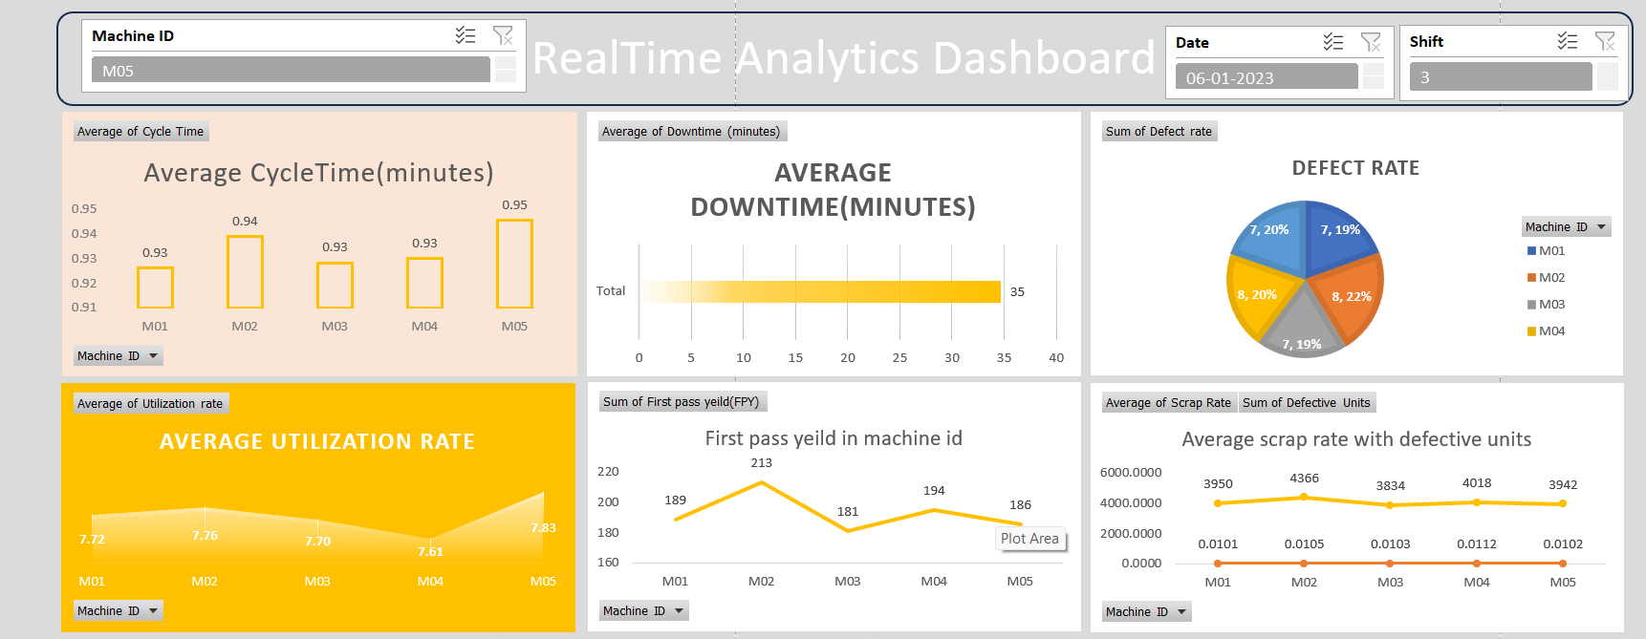

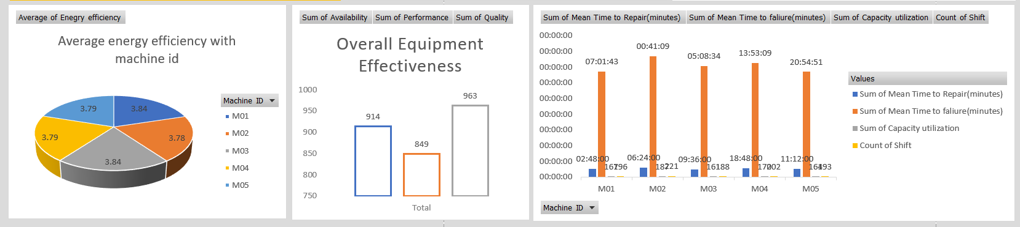

**Progress**

* **Accomplishments:**

1. Real-Time Monitoring: Continuous tracking of production metrics like OEE and downtime.
2. Improved Decision-Making: Faster, data-driven insights for production and maintenance.
3. Performance Optimization: Identified inefficiencies to improve cycle time and utilization.
4. Quality Control: Reduced defects and scrap rates to enhance product quality.
5. Energy Efficiency: Monitored energy consumption per unit for better management.
6. Order Management: Optimized lead time and order fulfillment tracking.
7. Maintenance Efficiency: Improved machine maintenance using MTTR and downtime data.
8. KPI Visualization: Clear visualizations of KPIs for operational insights.

* **Metrics:**

1. Measures overall performance, accounting for availability, performance, and quality.
2. Average time taken to produce one unit.
3. Total downtime in minutes per machine or shift.
4. Percentage of defective units out of total units produced.
5. Percentage of scrap units out of total units produced.
6. Total energy consumed (kWh) during production.
7. Percentage of actual output compared to maximum production capacity.
8. Percentage of units produced correctly without rework.
9. Average time taken to repair equipment.
10. Percentage of orders fulfilled compared to orders received.
11. Average time taken to complete orders.
12. Average time from order placement to fulfillment.
13. Total units produced per shift or machine.

**Challenges and Solutions**

* **Challenges Faced:**

1. Difficulty in aggregating data from various sources and systems.
2. Ensuring the data collected is accurate and reliable for analysis.
3. Keeping track of the dashboard's performance and functionality.

* **Solutions Implemented:**

1. Use data connectors and APIs for seamless data flow.
2. Establish data validation processes and regular audits to maintain data integrity.
3. Set up monitoring tools for dashboard performance.

**Next Steps**

* **Upcoming Tasks:** To effectively face upcoming tasks, prioritize clear objectives, leverage available resources, and maintain open communication with team members for support and collaboration.
* **Goals:** Stay focused, prioritize tasks, and take one step at a time to achieve my goals.

**Conclusion**

* **Summary:** The real-time analytics dashboard in the manufacturing sector empowers data analysts to monitor key performance metrics effectively, driving informed decision-making. By integrating data seamlessly and providing actionable insights, it enhances operational efficiency and quality control. Ultimately, this tool supports continuous improvement and aligns production processes with strategic goals.
* **Acknowledgements:** Thank you all for your attention and engagement, I appreciate your interest in the Real time Analytics dashboard in the Manufacturing sector.